Franklin County CROP Hunger Walk registration is open

No one in this world should be hungry. That's why the Franklin County CROP Hunger Walk is more than just a gathering of people in a place. We're part of a movement, taking steps and raising funds together to provide meals for those in our own community who need them - and supporting programs that create greater food security in communities all around the world. Please join in us in the fight against hunger. The steps we take and funds we raise will make a difference in the lives of others.

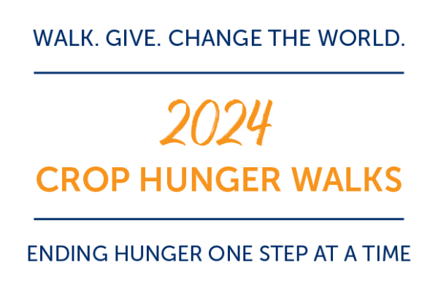

Want to be part of a group? Check out the list of teams already started

- or create your own! Visit the website: <https://events.crophungerwalk.org/cropwalks/event/shelburnema>

**Sunday - October 6, 2024**

**1:00 pm Registration, 2:00 Walk begins**

The walk will be starting and ending from:

First Congregational Church of Shelburne UCC

22 Church

Shelburne, MA 01370 USA

Contact

Steve Damon [damons_of_gill@yahoo.com](mailto:damons_of_gill@yahoo.com)